# Want to Build a Career in Data Science? Here's How to Get Started

You’ve probably heard the term Data Science amidst the AI boom, often hailed as one of the sexiest careers of the 21st century. You might be thinking of becoming one, especially in this data-driven era where turning data from your company or even personal data collected over time into meaningful insights is increasingly valuable. I'll guide you through how to build the necessary skills to become a data scientist, and some job-searching tips to help you land your first role.  
To become a data scientist, you can pursue a formal education route or opt for self-learning. Nowadays, various universities offer undergraduate degrees specifically in data science. Alternatively, you can kick start your career with a curated self-learning program. This can be achieved through short courses or by gathering resources on your own, dedicating around six months to focused study. Both pathways can equip you with the essential skills needed for the field. Regardless of the path you choose, here are some of the essential skills and educational background needed to become a good data scientist,You should understand that data science is a multidisciplinary field, combining knowledge from various domains.  
Education  
**1. Foundational Knowledge**To build a strong foundation in data science, it’s essential to have a solid understanding of certain fundamental subjects:



* Mathematics and Statistics: A deep understanding of statistics and linear algebra is crucial. These form the backbone of most data science algorithms and techniques. Courses in probability, hypothesis testing, and statistical inference will be particularly beneficial.



* Computer Science: Basic programming skills are essential. Learning languages like Python and R, which are widely used in data science for their ease of use and robust libraries, is highly recommended. Additionally, knowledge of databases and SQL is important for data manipulation and querying.

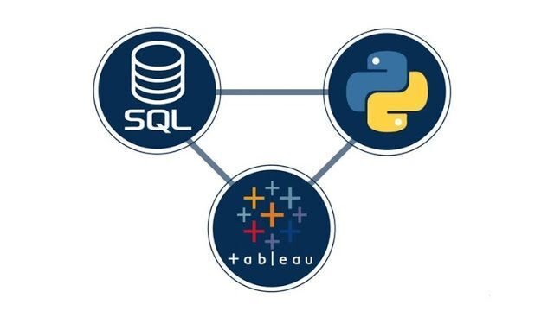

**2. Practical Experience**Hands-on experience is crucial in data science. Engage in projects that require you to analyze real data sets, participate in Kaggle competitions, or contribute to open-source data science projects. This will not only strengthen your skills but also provide a portfolio to showcase to potential employers.  
Recommended Platforms and Resources:  
· Kaggle: Participate in competitions and work on real-world datasets to build your portfolio.  
· DataCamp: Offers numerous interactive courses and projects to practice data science skills.  
· GitHub: Contribute to open-source projects and create repositories showcasing your work.  
[ata science skills.  
· GitHub: Contribute to open-source projects and create repositories showcasing your work.](https://media.dev.to/cdn-cgi/image/width=800%2Cheight=%2Cfit=scale-down%2Cgravity=auto%2Cformat=auto/https%3A%2F%2Fdev-to-uploads.s3.amazonaws.com%2Fuploads%2Farticles%2Fel7rpazrh78vhijwhd8h.jpeg)  
After building a strong educational foundation, these are some of the skills you should focus on mastering:  
**1. Programming Skills:**· Python: The go-to language for data science due to its simplicity and vast ecosystem of libraries.  
· R: Especially useful for statistical analysis and visualization.  
· SQL: Essential for database management and manipulation.  
**2. Data Manipulation and Cleaning:**· Pandas: A powerful Python library for data manipulation and analysis.  
· Numpy: A fundamental package for scientific computing with Python.  
**3. Data Visualization:**· Matplotlib: A comprehensive library for creating static, animated, and interactive visualizations in Python.  
· Seaborn: Built on top of Matplotlib, it provides a high-level interface for drawing attractive statistical graphics.  
· Tableau: A powerful tool for creating interactive and shareable dashboards.  
**4. Machine Learning:**· Scikit-Learn: A Python module integrating a wide range of state-of-the-art machine learning algorithms.  
· TensorFlow and Keras: Frameworks for building and training deep learning models.  
**Job Searching Tips**Once you've acquired the necessary skills, here are some tips to help you land a job in data science:



1. Networking: · Join data science communities, attend meetups, and engage with professionals on LinkedIn. · Participate in hackathons and industry conferences.
2. Building a Strong Portfolio: · Create a GitHub repository showcasing your projects and code. · Participate in Kaggle competitions and include your achievements in your portfolio.
3. Crafting a Good Resume: · Tailor your resume to highlight relevant skills and experiences. · Look for entry-level positions or internships that offer hands-on experience.

**Conclusion**Embarking on a career in data science requires a blend of strong foundational knowledge, practical skills, and strategic job searching. By leveraging the recommended courses and resources, gaining hands-on experience through projects and competitions, and effectively networking and preparing for job interviews, you can position yourself for success in this exciting and dynamic field. Remember, the journey to becoming a proficient data scientist is continuous, always be curious.